**Experiment 10**

**Aim :** To check if the graph is Cyclic or Acyclic

**Theory :** In graph theory, a cyclic graph contains at least one cycle, while an acyclic graph has no cycles. A cycle in a graph is a path that starts and ends at the same vertex, traversing distinct edges without repeating vertices except for the starting and ending vertices.

To check if a graph is cyclic or acyclic, various algorithms can be applied. One common approach is using Depth-First Search (DFS) to detect cycles in an undirected graph. Here's how it works:

An **adjacency list** is a data structure used to represent connections or relationships between vertices (or nodes) in a graph. It's a compact way to store a graph where each vertex in the graph is associated with a list of its neighboring vertices.

**Detecting Cycles Using DFS:**

* Initialization: Start DFS traversal from any vertex.
* Traverse Graph: While traversing the graph, mark each visited vertex.
* Back Edge Detection: While exploring edges from a vertex, if DFS visits an adjacent vertex that's already visited and isn't the parent of the current vertex (in the DFS traversal), it indicates the presence of a cycle.

**Algorithm -**

**Graph Creation:-**

**Classes:**

* ListNode: Represents a node in the graph. It contains an integer data and a pointer next to the next node in the linked list.
* List: Implements a linked list to maintain vertices. Each element in this list is a ListNode.
* Graph: Represents the graph structure. It contains:
  + V - The number of vertices in the graph.
  + adjacencyList - An array of List objects. Each element of this array represents a vertex in the graph. Each List maintains the adjacent vertices for the corresponding vertex.

**Graph Representation:**

* Adjacency List:
  + adjacencyList is an array of List objects, where each index represents a vertex.
  + Each List maintains the adjacent vertices for a specific vertex using a linked list (ListNode).
  + push_back(int val): Adds a new node to the end of the linked list in the List object.
  + getHead(): Returns the head of the linked list associated with a particular vertex.

**Graph Operations:**

* Constructor (Graph(int V) { ... }):
  + Initializes the graph with V vertices.
  + Allocates memory for the adjacency list, creating an array of List objects.
* addEdge(int v, int u):
  + Adds an edge between vertices v and u.
  + Updates the adjacency list for both v and u by adding the opposite vertex to each other's lists.
* checkCycle():
  + Detects whether the graph contains any cycles.
  + Utilizes DFS through checkCycleUtil() to traverse the graph, marking visited vertices and checking for cycles.
* printGraph():
  + Displays the adjacency list representation of the graph.
  + Prints each vertex along with its adjacent vertices.

**Main Function:**

* User Interaction:
  + Asks the user for the number of vertices and edge inputs until -1 -1 is entered.
  + Constructs the graph by adding the provided edges.
  + Checks if the graph contains cycles and prints the result.
  + Prints the adjacency list representation of the graph.

**Cyclic or Acyclic:-**

**checkCycleUtil() Function:**

* This function is a utility for the cycle detection process. It is called recursively from checkCycle() to perform the cycle check.

checkCycle() Function:

* **Initialization:**
  + Initializes a boolean array visited to keep track of visited vertices.
  + Loops through each vertex in the graph.
* **Cycle Detection:**
  + Calls the checkCycleUtil() function for each unvisited vertex.
  + Inside checkCycleUtil():
    - Marks the current vertex as visited and explores its adjacent vertices.
    - If an adjacent vertex is visited and is not the parent of the current vertex, a cycle is detected.
* **Return Result:**
  + If the checkCycleUtil() detects a cycle during the traversal, the checkCycle() function returns true, indicating that the graph contains a cycle.
  + If no cycle is detected after checking all vertices, the function returns false, indicating that the graph is acyclic.

**Cycle Detection Logic:**

* Uses a DFS-based approach to explore the graph.
* While traversing, it marks visited vertices and tracks the parent of each vertex.
* Detects a cycle if it encounters a visited vertex that isn't the parent of the current vertex.

**Code:-**

**#include <iostream>**

**using namespace std;**

**class *ListNode* {**

**public:**

**int data;**

***ListNode*\* next;**

**ListNode(int val) : data(val), next(nullptr) {}**

**};**

**class *List* {**

**private:**

***ListNode*\* head;**

**public:**

**List() : head(nullptr) {}**

**void push_back(int val) {**

***ListNode*\* newNode = new *ListNode*(val);**

**if (!head) {**

**head = newNode;**

**return;**

**}**

***ListNode*\* temp = head;**

**while (temp->next != nullptr) {**

**temp = temp->next;**

**}**

**temp->next = newNode;**

**}**

***ListNode\** getHead() {**

**return head;**

**}**

**};**

**class *Graph* {**

**int V;**

***List*\* adjacencyList;**

***// void DFS(int v, bool visited[]) {***

***// visited[v] = true;***

***// ListNode* headNode = adjacencyList[v].getHead();***

***// while (headNode) {***

***// int adjVertex = headNode->data;***

***// if (!visited[adjVertex]) {***

***// DFS(adjVertex, visited);***

***// }***

***// headNode = headNode->next;***

***// }***

***// }***

**bool checkCycleUtil(int v, bool visited[], int parent) {**

**visited[v] = true;**

***ListNode*\* headNode = adjacencyList[v].getHead();**

**while (headNode) {**

**int adjVertex = headNode->data;**

**if (!visited[adjVertex]) {**

**if (checkCycleUtil(adjVertex, visited, v))**

**return true;**

**} else if (adjVertex != parent) {**

**return true;**

**}**

**headNode = headNode->next;**

**}**

**return false;**

**}**

**public:**

**Graph(int V) {**

**this->V = V;**

**adjacencyList = new *List*[V];**

**}**

**void addEdge(int v, int u) {**

**adjacencyList[v].push_back(u);**

**adjacencyList[u].push_back(v);**

**}**

**bool checkCycle() {**

**bool* visited = new bool[V]();**

**for (int i = 0; i < V; ++i) {**

**if (!visited[i] && checkCycleUtil(i, visited, -1)) {**

**delete[] visited;**

**return true;**

**}**

**}**

**delete[] visited;**

**return false;**

**}**

***// bool isConnected() {***

***// bool* visited = new bool[V]();***

***// DFS(0, visited);***

***// for (int i = 0; i < V; ++i) {***

***// if (!visited[i]) {***

***// delete[] visited;***

***// return false;***

***// }***

***// }***

***// delete[] visited;***

***// return true;***

***// }***

**void printGraph() {**

**for (int i = 0; i < V; ++i) {**

**cout << "Vertex " << i << " --> ";**

***ListNode*\* currentNode = adjacencyList[i].getHead();**

**while (currentNode) {**

**cout << currentNode->data << " ";**

**currentNode = currentNode->next;**

**}**

**cout << endl;**

**}**

**}**

**};**

**int main() {**

**int v, u;**

**cout<<"Enter the number of vertices in the graph "<<endl;**

**int vertices;**

**cin>>vertices;**

***Graph* g(vertices);**

**cout << "Enter edges (Vertex1 Vertex2) [-1 -1 to stop]:\n";**

**while (true) {**

**cin >> v >> u;**

**if (v == -1 && u == -1)**

**break;**

**g.addEdge(v, u);**

**}**

**if (g.checkCycle())**

**cout << "Graph is cyclic" << endl;**

**else**

**cout << "Graph is acyclic" << endl;**

***// if (g.isConnected())***

***// cout << "Graph is connected" << endl;***

***// else***

***// cout << "Graph is not connected" << endl;***

**g.printGraph();**

**return 0;**

**}**

**Example 1:-**

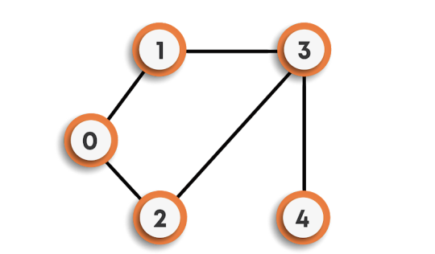

**Input:-**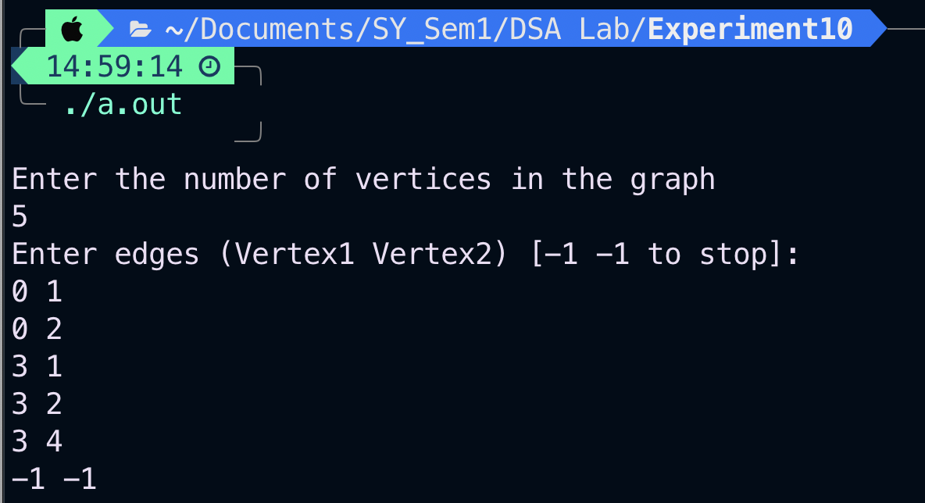

**Structure of Graph:-**

**Vertex 0 --> 1 2**

**Vertex 1 --> 0 3**

**Vertex 2 --> 0 3**

**Vertex 3 --> 1 2 4**

**Vertex 4 --> 3**

**Output:-**

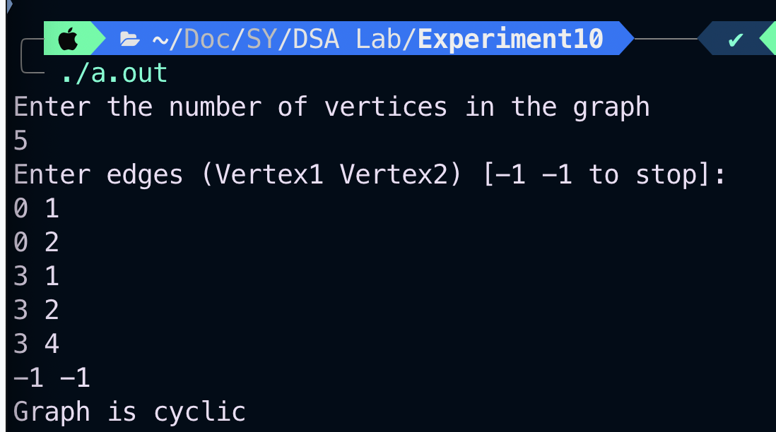

**Example 2 -**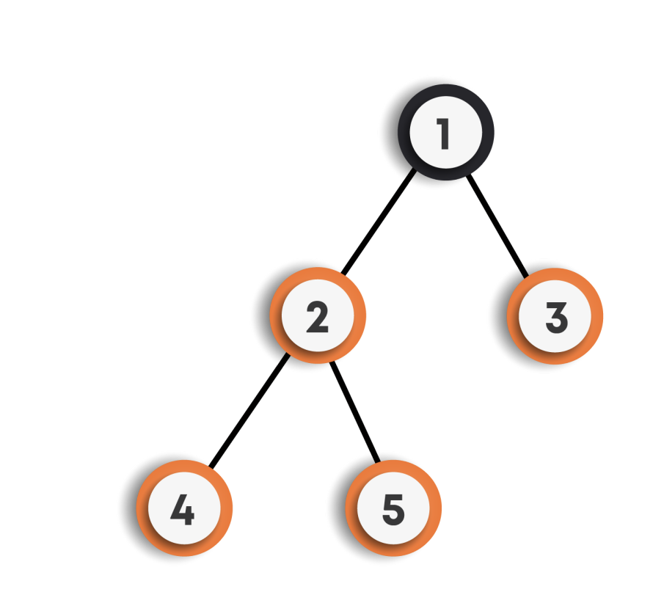

**Structure of graph:-**

**Vertex 0 -->**

**Vertex 1 --> 2 3**

**Vertex 2 --> 1 4 5**

**Vertex 3 --> 1**

**Vertex 4 --> 2**

**Input and Output:-**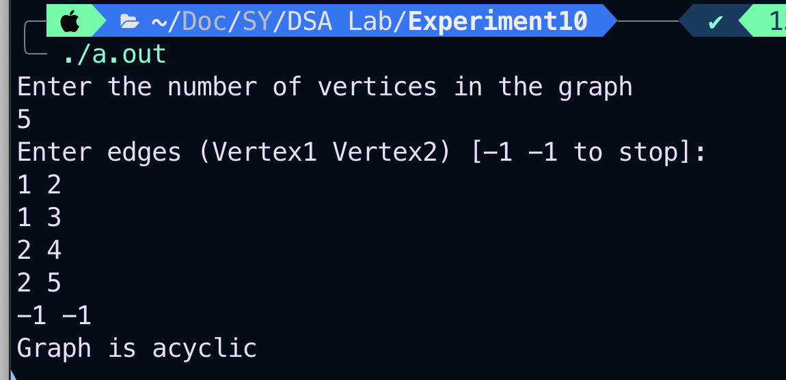

**Conclusion** - From this experiment, we learned how to implement the graph using adjacency list and how to detect if there is a cycle in the graph using dfs traversal.